Test Automation & Advanced Selenium
Lab Book Version 1.2

Document Revision History

Date | Revision No. | Author | Summary of Changes
Jan 2016 | 1.1 | Ritika Verma – Automation CoE | Material Revamp

Table of Contents
Document Revision History 2
Table of Contents 3
Getting Started 4
Lab Demo 1: Example (Basic Selenium IDE Flow) 5
Lab Demo: Example (Selenium IDE) (Cont.) 6
Lab Demo: Example (Selenium IDE) (Cont.) 7
Lab Demo 2: Learning Selenium IDE (Modifications) 8
Lab 1. Learning Selenium IDE(Basic Flow) 9
Lab 2. Learning Selenium IDE(Performing Validations) 11
Lab 3. Create a new account (using Selenium Webdriver) 12
Lab 4. Validations in Selenium (using Selenium Webdriver) 14
Lab 5. Alert and window handling (using Selenium Webdriver) 15
Lab 6. WebDriver with JUnit/TestNG (using Selenium Webdriver with Junit and TestNG) 16
Lab 7. Advance Selenium (Chrome Driver and IE Driver) 17
Lab 8. Advance Selenium (RemoteWebDriver) 18
Appendices 19
Appendix A: Selenium Standards 19

Getting Started

Overview
This lab book is a guided tour for learning Test Automation & Advanced Selenium. It comprises solved examples and ‘To Do’ assignments. Follow the steps provided in the solved examples and work out the ‘To Do’ assignments given.

Setup Checklist for Selenium
Here is what is expected on your machine in order for the lab to work.
Minimum System Requirements
- Intel Pentium 90 or higher (P166 recommended)
- Microsoft Windows 95, 98, or NT 4.0, 2k, XP.
- Memory: 512MB of RAM
- Internet Explorer 6.0 or higher
- Mozilla Firefox( Add-ons: Firebug, Firepath, Selenium IDE)

Instructions
- For all coding standards refer Appendix A. All lab assignments should refer coding standards.
- Create a directory by your name in drive <drive>. In this directory, create a subdirectory Selenium Assign. For each lab exercise create a directory as lab <lab number>.

Lab Demo 1: Example (Basic Selenium IDE Flow)

Goals | - Understand the process of automation testing of a web application on Selenium IDE  - Learn to manage document spacing
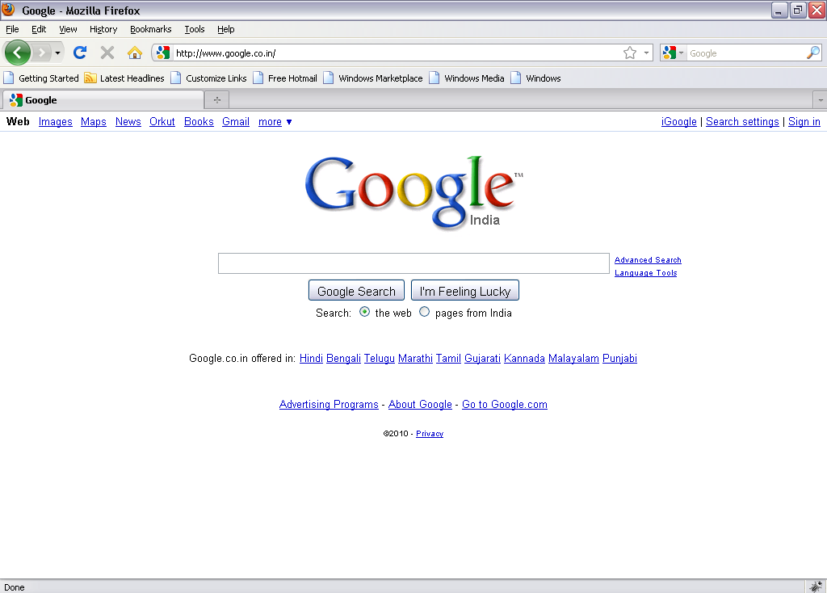  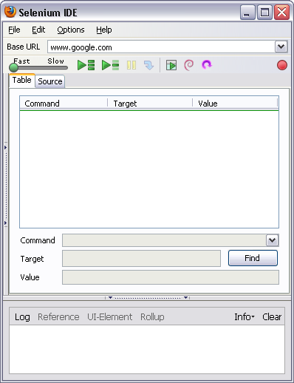  Time | 60 minutes  Go to the Web Page for which you want to carry out the test  Hit the record button on IDE

Lab Demo: Example (Selenium IDE) (Cont.)

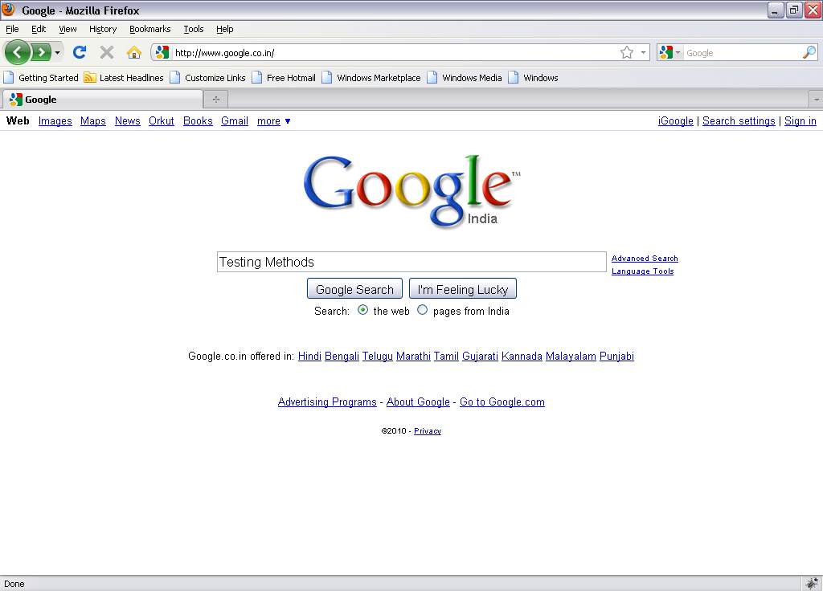

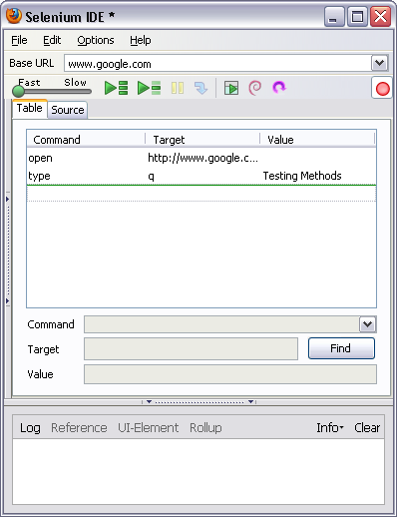
Play Button
Enter the text on Web Page and submit
IDE should be updated, stop the recorder and add the assertions

Lab Demo: Example (Selenium IDE) (Cont.)

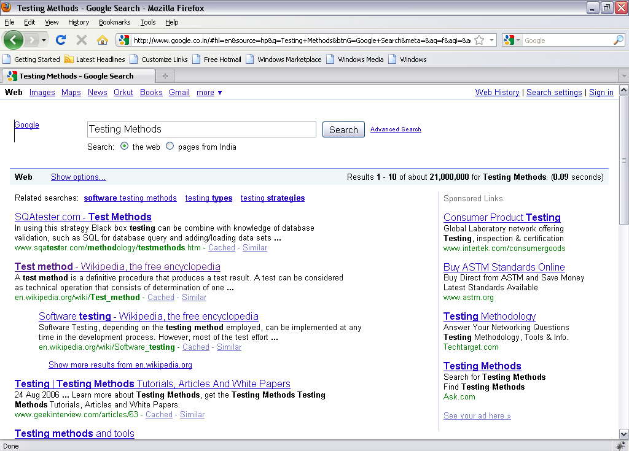
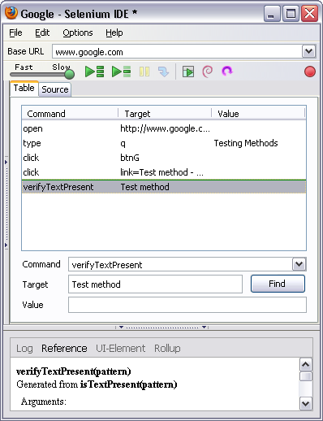
Hit the play button to play the recorded scripts
Play Button
Perform operations on the web page

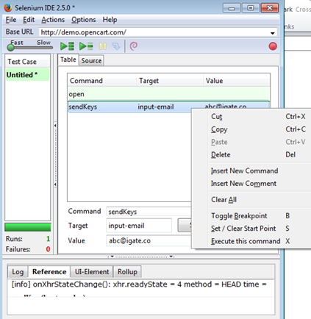
Lab Demo 2: Learning Selenium IDE (Modifications)
Goals | - Understand the process of further modifications and validations in automation testing of a web application on Selenium IDE  - Learn to manage document spacing
Time  Basic URL: http://demo.opencart.com/  - Follow the steps from Lab Demo 1  - In order to add new command, go to the command where the new command needs to be added and then do right click , click on ‘Insert New Command’  - ‘Command’ dropdown provides options/ keywords to perform the operation  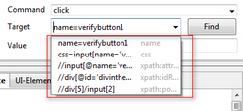 | 60 minutes
- Learning Selenium IDE(Basic Flow)

Goals | - Understand the basic process of automation testing of a web application in Selenium IDE  - Learn to manage document spacing
Time | 60 minutes

Basic URL: http://demo.opencart.com/

- Open the URL on Firefox
- Start recording on Selenium IDE
- Go to 'Desktops' tab
- Click on 'Mac'
- Select 'Name(A-Z)' from the 'Sort By' dropdown
- Click on 'Add to Cart' button
- Stop the recording on Selenium IDE
- Playback the whole test case

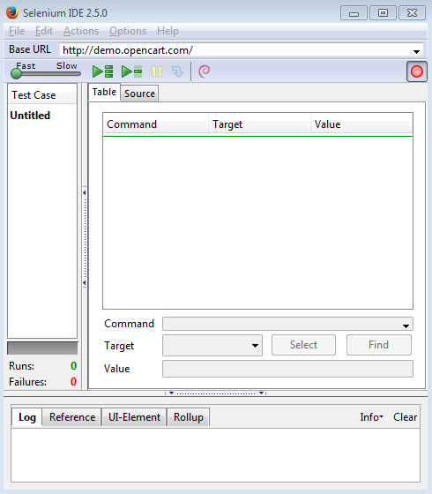
- Learning Selenium IDE (Performing Validations)

Goals | - Understand the process of automation testing of a web application  - Learn to manage document spacing
Time | 60 minutes

Basic URL: http://demo.opencart.com/

- Open the URL on Firefox
- Start recording on Selenium IDE
- Verify title of the page
- Go to 'Desktops' tab
- Click on 'Mac'
- Select 'Name(A-Z)' from the 'Sort By' dropdown
- Click on 'Add to Cart' button
- Enter ‘Mobile’ in ‘Search’ text box and click on ‘Search’ button
- Wait for page to load
- Clear the text from ‘Search Criteria’ text box
- Click on ‘Search in product descriptions’ check box and click on ‘Search’ button
- Stop the recording on Selenium IDE
- Add the step after Step 5 where verify the 'Mac' heading
- Change the value from ‘Mobile’ to ‘Monitors’
- Save the test case
- Playback the whole test case.
- Playback set by step
- Add the step after Click on 'Mac' where verify the 'Mac' heading
- Save the test case
- Export the test case as 'Java/JUnit/webDriver'
- Run the whole Test case and check the 'Pass' Status
- Create another test case with the same flow
- Create the test suite for the above test cases
- Create a new account (using Selenium Webdriver)

Goals | - Understanding the scenario from end to end and automating the same  - Analyze the requirement and perform validations accordingly
Time | 120 minutes

Basic URL: http://demo.opencart.com/

Please ensure that the variables have to be defined before it is being used.

Part 1: Launch Application

- Launch the URL on Firefox
- Verify 'Title' of the page
- Click on 'My Account' dropdown
- Select 'Register' from dropdown
- ‘Register Account’ page will open up, verify the heading ‘Register Account’
- Click on 'Continue' button at the bottom of the page
- Verify warning message 'Warning: You must agree to the Privacy Policy!'

Automate and validate the different sections of ‘Register Account’ page:

Part 2: For 'Your Personal Details'

- Enter data in 'First Name' text box
- Verify if 33 characters can be entered in 'First Name' text box by clicking on 'Continue' button.
- If not, verify error message.
- Enter data in 'Last Name' text box
- Verify if 33 characters can be entered in 'First Name' text box by clicking on 'Continue' button.
- If not, verify error message.
- Enter valid 'E-mail'.
- Enter 'Telephone' which must be between 3 and 32 characters.

Part 3: For 'Your Address'

- Enter 'Address 1' which should contain characters between 3 and 128
- Enter 'City' which should contain characters between 2 and 128
- Enter 'Post Code' which should contain characters between 2 and 10
- Select 'India' from 'Country' Dropdown
- Select 'Region/State' from dropdown

Part 4: For 'Password'

- Enter 'Password' which must be between 4 and 20 characters.
- Enter 'Password Confirm'.

Part 4: For 'Newsletter'

- Click on 'Yes' Radio button
- Click on checkbox for 'I have read and agree to the Privacy Policy'.
- Click on 'Continue' button
- Verify message 'Your Account Has Been Created!'
- Click on 'Continue'
- Click on link 'View your order history' under 'My Orders'

- Validations in Selenium (using Selenium Webdriver)
Goals | - Understanding the scenario from end to end and automating the same
Time | 120 minutes

Basic URL: http://demo.opencart.com/

After login on the ‘Open Cart’, create a test script following the below mentioned steps:

- Login with credentials created in Lab 1
- Go to 'Components' tab and click
- Select 'Monitors'
- Select 25 from 'Show' dropdown
- Click on 'Add to cart' for the first item
- Click on 'Specification' tab
- Verify details present on the page
- Click on 'Add to Wish list' button.
- Verify message 'Success: You have added Apple Cinema 30" to your wish list!'
- Enter 'Mobile' in ' Search' text box.
- Click on 'Search' button
- Click on 'Search in product descriptions' check box
- Click on link 'HTC Touch HD' for the mobile 'HTC Touch HD'
- Clear '1' from 'Qty' and enter '3'
- Click on 'Add to Cart' button
- Verify success message 'Success: You have added HTC Touch HD to your shopping cart!'
- Click on 'View cart' button adjacent to search button
- Verify Mobile name added to the cart
- Click on 'Checkout' button
- Click on 'My Account' dropdown
- Select 'Logout' from dropdown
- Verify 'Account Logout' heading
- Click on 'Continue'
- Alert and window handling (using Selenium Webdriver)
Goals | Learning alert handling and window handling basics in selenium webdriver
Time | 120 minutes

Base URL: https://ispace.ig.capgemini.com/sitepages/index.aspx

- Launch the URL
- Go to 'Application' tab
- Click on checkbox 'Stationery Request'
- Verify the new title ‘Stationary’
- On ‘Stationery’ tab, click on 'Submit to collect your Stationery >>>' link
- Switch to alert as shown below.
- Verify text on the alert 'Please add product(s) to cart'
- Verify if 'Ok' button is present on the alert
- Click on 'Ok' button
- Click on ‘Photocopy’ tab, click on ‘Save Request’ button
- Switch to alert and verify text ‘No changes made’
- Verify if ‘Ok’ button is present
- Click on ‘Ok’ button present on alert
- Click on ‘Logout’ button
- Close the ‘Stationery’ window

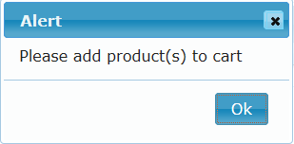

- WebDriver with JUnit/TestNG (using Selenium Webdriver with Junit and TestNG)
Goals | Learning how to write webdriver automation test cases using Junit and TestNG
Time | 120 minutes

- Consider the flow mentioned in Lab 3 & Lab 4, complete the task using Selenium WebDriver and JUnit.
[NOTE: All the verifications should be using JUnit Assertions]

- Consider the flow mentioned in Lab 3 & Lab 4, complete the task using Selenium WebDriver and TestNG.
[NOTE: All the verifications should be using TestNG Assertions. Test cases should have proper TestNG Reporter logging as well.]

- Create one TestNG test suite for both the test cases created for question number 2 along with testing.xml and execute the test suite. Provide the Reports as well.

- Advance Selenium (Chrome Driver and IE Driver)
Goals | Learning how to write webdriver automation test cases for Chrome and IE browser
Time | 120 minutes

- Consider the flow mentioned in Lab 3 & Lab 4, make necessary changes to execute the same flow on both Chrome and Internet Explorer browser.

- Consider the Question number 1 and make it JUnit test case.
[NOTE: All the verifications should be using JUnit Assertions]

- Advance Selenium (RemoteWebDriver)
Goals | Learning how execute Selenium scripts using RemoteWebDriver
Time | - minutes

- Consider the flow mentioned in Lab 3 & Lab 4, make necessary changes to execute the same flow using RemoteWebDriver and Selenium Grid on Firefox, Chrome and Internet Explorer browser.
[NOTE: Set Platform, BrowserName and Version to DesiredCapabilities]

- Consider the flow mentioned in Lab 4 and take screenshot after each steps. Save all the screenshots inside a folder called ‘Screenshots’ in the root of the Java project.

Appendices

Appendix A: Selenium Standards

Key points to keep in mind:
Selenium standards help you reach the widest possible audience.
There are many technologies that are associated with HTML because they are used on web pages or in conjunction with HTML.

For each of the above, please follow coding conventions specified by that technology.
Sometimes you are going to have to break rules and use non-standard syntax for good reason. Try to keep this to the minimum.

How to follow Selenium standards:
See the W3C site for more information on locator types and keyword statements.
The important thing to remember is that proper keywords are essential to assist validation software in checking your document.
Use Selenium IDE to find the locators for the elements.
Refer to W3C for technical and syntax information.
Always use the comments with the codes for proper understanding.

Some simple Selenium standards:
Names of Selenium files should always end with the extension .java.
Correct: foo.java
Incorrect: foo.bar

